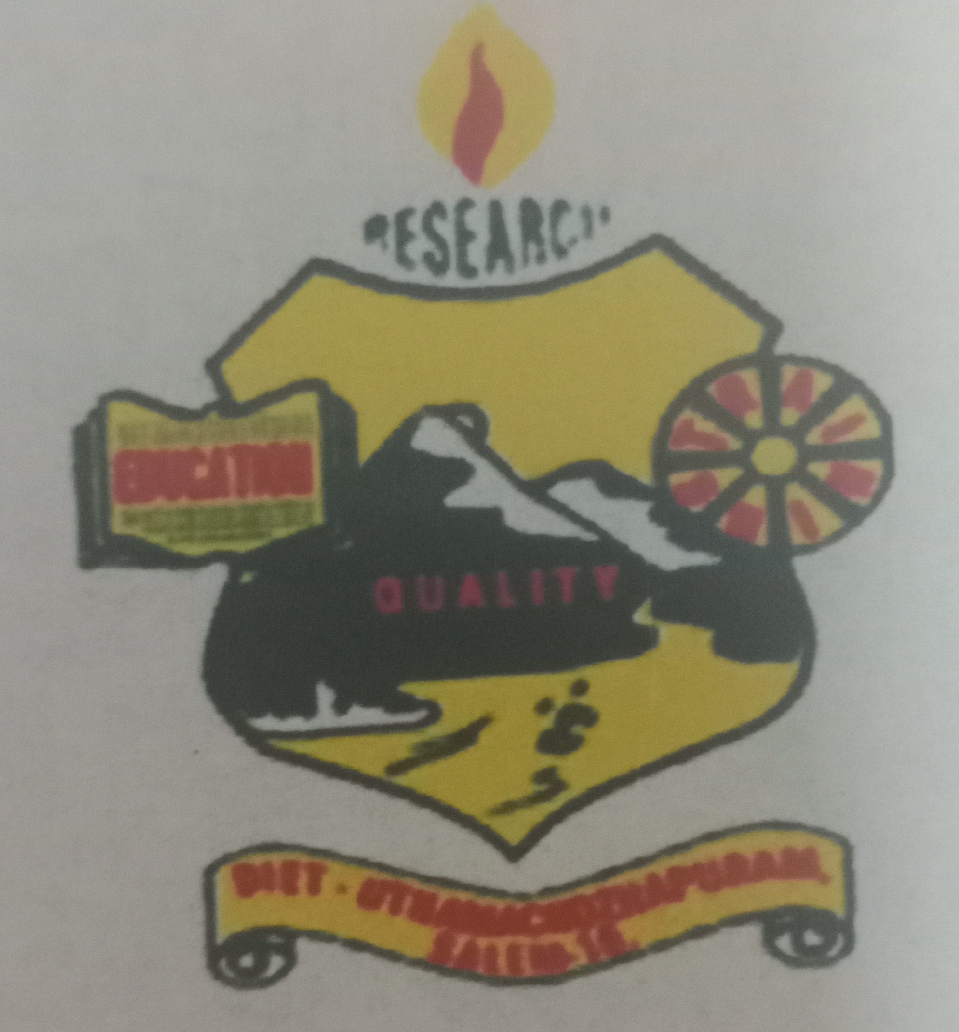
DISTRICT INSTITUTE OF EDUCATION AND TRAINING INSTITUTE
UTHAMACHOLAPURAM-SALEM-636010
March - 2021 PREPARED BY: PSTE VOL: 4 NO:3

SPECTRUM
ECHO OF DIET SALEM
EE
Ece

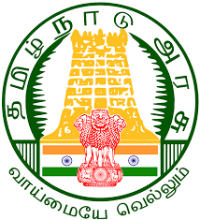

The Science behind the Vaccines

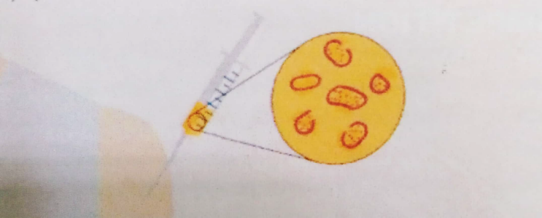
Polio, Measles, Diphtheria, Pertussis (whooping cough). Rubella, Mumps, Tetanus, Rotavirus infections were some of the deadliest diseases of our time that can now be easily prevented by vaccination. Thanks to a vaccine, such diseases mostly no longer exist outside the laboratory. Over the years, vaccines have saved millions of lives around the world. Even at present global COVID-19 pandemic condition, vaccines proved to be the only saviour. Let's find out, what is a vaccine? How it works? Different types of vaccine, and how they get approval before coming into the market.
Vaccine: A vaccine is a biological agent that prevents us from infectious disease-causing pathogens such as viruses, bacteria, or parasites. It guides the body on defending itself against the pathogen attack by generating an immune response. Usually, it is administered in our body in liquid form, either by injection, oral doses, or intranasal routes.
How vaccines work: A disease-causing organism can cause two types of responses in our body. The first can be seen as symptoms such as fever, nausea, vomiting, diarrhoea, rash etc. which we experience initially. The second is the immune system's response to the infection. Over time the strength of the immune system increases, which in turn reduces the number of infectious agents and slowly the symptoms disappear.

Vaccines are composed of either the entire disease causing microorganism or some of its components in non-pathogenic form which imitate the second type of response without the consequences of the first. The following steps summarize how a preventive vaccine can protect an individual from infection or disease:
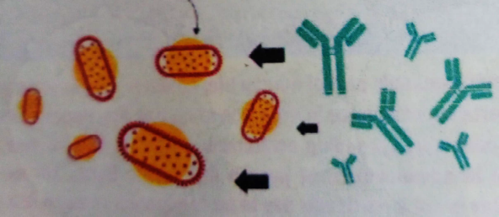
- The vaccine introduces a small component or a non-harmful form of the pathogen into the body. This is called the foreign antigen or immunogen. 2. The body's immune system produces an immune response to the pathogen by generating antibodies, killer cells, or both. 3. A small group of “memory" B-cells and T-cells remain in the body and can quickly initiate a strong immune response, i.e., by producing antibodies and helping the production of killer T-cells or antibodies, respectively. The next time the real pathogen enters the body, the immune system remembers it and mounts a much larger, quicker response than it would have if the individual had never received the vaccine
Vaccine Testing and Approval Process: Most vaccines have been in use for decades, with millions of people receiving them safely every year. Like medicines, every vaccine goes through extensive and rigorous testing to ensure it is safe before it can be introduced in a country's vaccine programme. Each vaccine under development is evaluated to determine which antigen should be used to evoke an immune response. The pre-clinical phase is carried out without testing on humans. An experimental vaccine is first tested on animals to evaluate its safety and potential to prevent disease. If the vaccine triggers an immune response, it is then tested in human clinical trials in three phases.
Phase 1 The vaccine is given to a small variety of volunteers to assess its safety, ensuring that it generates an immune response, and dose is decided. During this phase the vaccines are usually tested on young and healthy adult volunteers.

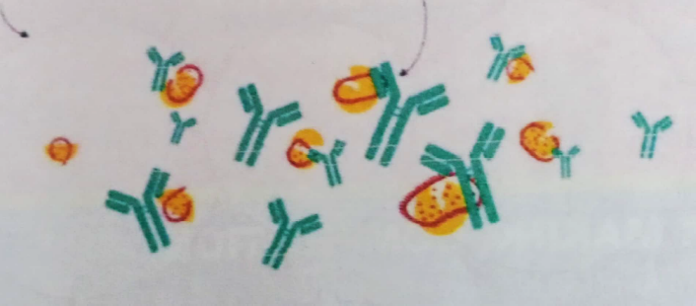
Phase 2 The vaccine is then given to hundreds of volunteers to further assess its safety and ability to generate an immune response. Participants in this phase have an equivalent characteristic as the people for whom the vaccine is meant. Multiple trials are usually conducted during this phase to evaluate different age groups and different formulations of the
vaccine. The group of people that did not get the vaccine is usually included in this phase as a comparator group to determine whether the changes in the vaccinated group are attributed to the vaccine or have happened without any cause.
Phase 3 The vaccine is then given to thousands of volunteers and compared with a similar group of people who didn't get the vaccine but received a comparator product. This is done to determine if the vaccine is effective against the disease it is designed to protect against and to study its safety in a much larger group of people. Most of the time, Phase 3 trials are conducted across multiple countries and multiple sites within a country to assure that the findings of the vaccine performance apply to many different populations. During Phase 2 and Phase 3 trials, the volunteers and the scientists conducting the study are not informed whether the volunteers had received the vaccine being tested or the comparator product. This is known as "blinding" and is necessary to assure that neither the volunteers nor the scientists are influenced in their assessment of safety or effectiveness by knowing which group had received which product. Once the trial is over and all the results are finalized, the volunteers and also the trial scientists are informed if they had received the vaccine or the comparator.
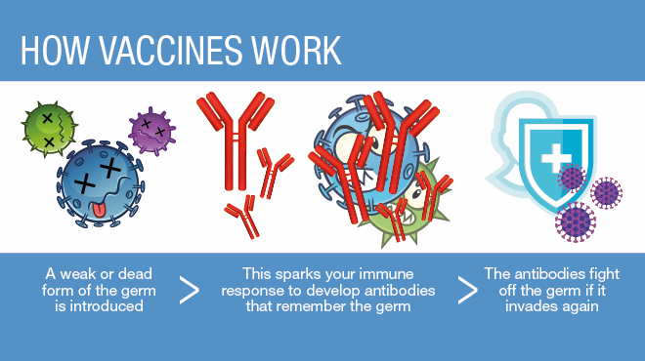
Courtesy by:
Dr Nidhi Shrivastava is Project Scientist at Vigyan Prasar.

Copyrig

Dr . Selvam, Principal
- Mrs .Shanti JD syllabus, review the program and activities of diet Salem on 02-03-2021.
- Integrated the spring workout science program on 03.03.2021.
- Imported training on special whoo, pee and tactics e-content for the DIKSHA Platform which was part of Dr. M. Selvam Action research on 04.03.2021.
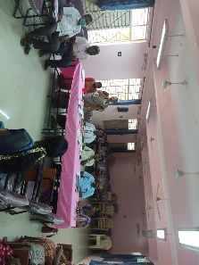
- Inaugurated Intervention of AR of Dr .GovindaPrakash, vice Principal at PUMSChinnakollapatty on 09.03.2021.
- Participated in ZARK Meeting at DIET Dharmapuri on 10.03.2021., Namakkal on 23.03.2021. and Salem on 22.03.2021.
- Inaugurated workshop on comprehensive learning which was a part of SeniorLecturer Mrs.G.Dhanammal’s AR at BRC Nangavalli and Senior Lecturer Prabakaran AR at DIET Salem On 15.03.2021.
- Inaugurated Action Research dissemination workshop at DIET- Salem From 24.03.2021.
- Inaugurated In-Service Training on Enriching the Science Content for KGBV Teachers on 25.03.2021.
- Inaugurated the Workshop on Value Bloomers which was a part of Lecturer Mrs.S.Selvi Research Project on 26.03.2021 and online training on assessment skill development through corselet which was a part of Senior Lecturer Dr.K.Kannaki Research Project.
- Integrated Online Training on 6th std Math Content Enrichment on 30.03.2021.

PRE - SERVICE TEACHER EDUCATION:(PSTE)
- 02.03.2021 05.03.2021 . Micro video preparation for 4th standard math was done by Mrs.M. Mahalakshmi.
- Tamil Language class was handled for Gangavalli- TTI students by M.Jayamani , Lecturer on 04.03.2021.
- Dr P.Govindaprakash acted as an Action Research Zonal committee member at DIET-Dharmapuri on10.03.2021.
- The Action Research work P Govinda Prakash, S. Peter Anand S. Selvi M. Mahalakshmi R.Ravi and M. Jayamani..
- 2019.-2021 Action Research Dissemination work P. Govinda Prakash, S. Peter Anand, S. Selvi M. MahaLakshmi,R.Ravi and M. Jayamani.,
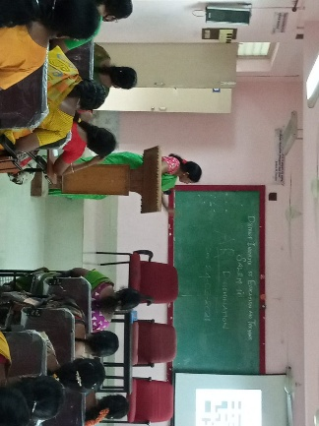
- The Action research presentation Program P. Govind Prakash, S. Peter Anand S. Selvi M. MahaLakshmi R.Ravi and M. Jayamani.
- Attended election class P Govinda Prakash, S. Peter Anand, S. Selvi , M. MahaLakshmi, R.Ravi and M. Jayamani..
- 18.03.2021 Election class attended by S. Peter Anand S. Selvi M. MahaLakshmi R.Ravi and M. Jayamani.
- 23.03.2021. Dr P.Govindaprakash acted as committee member for Action Research at DIET Namakkal.
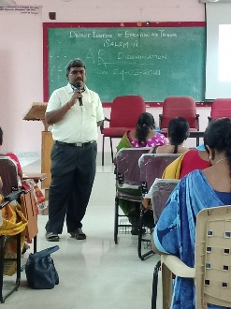
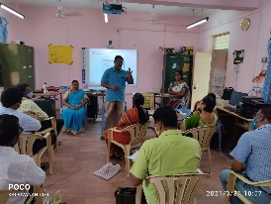
- 25.26.03. 019.-2021 Action research Dissemination work by P.Govinda Prakash, S. Peter Anand, S Selvi ,M. Mahalakshmi R.Ravi and M. Jayamani..
- 27.03.2021 Election class was attended by P. Govinda Prakash, S. Peter Anand, S. Selvi, M. MahaLakshmi R.Raviand M. jayamani,
- 30.03.2021 ATB workshop was conducted at DIET Salem by Mrs M.Jayamani..
- 31.03.2021 ATB workshop was conducted at DIET Salem by Mrs M.Jayamani.
IN-SERVICE FIELD INTERACTION INNOVATION AND COORDINATION:(IFIC)
- Involved in data collection work for the research project (a study on diverse emotional attributes of Orphan children in Institutional Homes.
- Organized a module preparation workshop for the training program content enrichment training for class 6th standard teachers.
- Conducted a module preparation of workshop for the project effect of learning management systems based training and research skill for teachers.
- Organized Content Enrichment training for class 6th in online mode
EDUCATIONAL TECHNOLOGY:(ET)
DATE | WORK DONE
10.3.21 | Action Research Work .
11.3.21 | Action Research Work .
16.3.21 | Content Enrichment Program .
22.3.21 | ZARC – Action Research..
23.3.21 | Content and Enrichment program .
24.3.21 | AR- Dissemination Work shop Program at DIET.
25.3.21 | AR-Dissemination Work shop Program at DIET.
26.3.21 | Training Programme conducted for Impact of Values Bloomers for Upper Primary Teachers.
29.3.21 | Action Research –Dissemination Work shop.
30.3.21 | Workshop Programme of Audio Book Preparation.  1. Basic Electrical Engineering.  2. Auto Mobile Engineering.

DISTRICT RESOURCE UNIT: (DRU)
NAME OF THE DIET FACULTY : Dr P.SO.KESAVAN, DRU BRANCH

Date | DETAILS OF WORK CARRIED OUT
2.3.2021 | DIET :DRU Branch Activities Reviewed by JD,SCERT CHENNAI.
3.3.2021 | Action Research – Field visit to schools.
5.3.2021 | Action Research – Field visit to schools.
27.3.2021 | Attended Election Class at Jai Ram Arts and Science College, Chinnathirupathy, Salem

CURRICULUM MATERIAL DEVELOPMENT EVALUVATION:(CMDE)
Name of the Faculty : Dr. R.Nagalakshmi
1. Action Research work from 01/03/21 to 23/03/2021.
2. Attended knowledge sharing Programme in Sri Sarada College of Arts and Science on 08/03/2021.
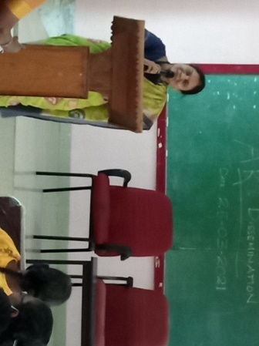
3. Conducted Zoom Training Programme for Science Teachers in Valapady Block as a part of Action Research work on 12/03/2021.
4. Attended Election Training class-1 at Vinayaka Missions Engineering college, Chinna Seeragapadi, Salem on 18/03/21.
5. Participated and presented Action Research before Zonal Action Research Committee (ZARC) on 22/03/2021.
6.Disseminated Action Research of 2019-20 to 2 batches at DIET on 24/03/2021.
7.Attended Election Training class-2 at GBHSS Attur on 27/03/21.
8. Carried out Research Project activities-editting videos in chemistry.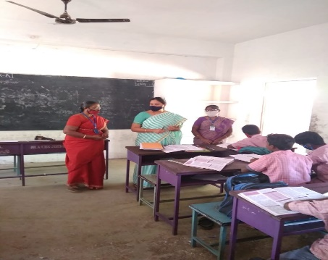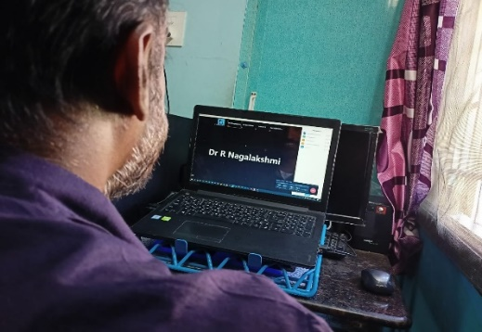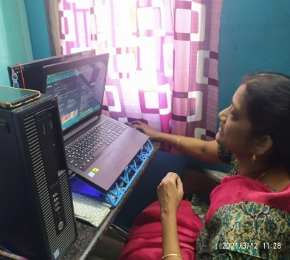

Name of the Faculty : B.Ananthi
1. Action Research work from 01/03/21 to 23/03/2021
2. Attended Election Training class-1 at Vinayaka Missions Engineering college, Chinna Seeragapadi, Salem on 18/03/21.
3. Participated and Presented Action Research before Zonal Action Research Committee (ZARC) on 22/03/2021.
4.Disseminated Action Research of 2019-20 to Two Batches at DIET on 24/03/2021.
5. Attended online meeting conducted by JD (Training), SCERT regarding DIKSHA content creation for English Standard 1 to 12 on 24/03/21.
6. Attended Election Training class-2 at Sri Shakthi Kailash Women's college, Ammapet, Salem on 27/03/21.
PLANNING AND MANAGEMENT : (P&M)
DATTE | WORK
01.03.2021 | Research work.
02.03.2021 | Attended Review Meeting by J.D-Syllabus, SCERT-Chennai regarding department work at Salem DIET.
21.03.2021 | Action Research
22.03.2021 | ZARK - Participated and Presented Action Research.
26.03.2021 | Online corselet training for research work.
30.03.2021- | Project work- online corselet programme at Salem Rural, Salem Urban, Sangagiri , Veerapandi and Omalur Blocks.
WORK EXPERIENCE : (WE)
NAME OF THE DIET FACULTY: Dr S.V.VIJAYALAKMI SHANKAR,
SENIOR LECTURER, WE BRANCH
Date | ACTIVITIES
01.3.2021 | Preparation of Webinar document & e-lesson plan for Saradha College of education
02.3.2021 | JD Review meeting
03.3.2021 | Arranged & coordinated for “off springs’ Diggings” for PUES, Karatupatti, Tharamangalam Block
04.3.2021 | Participated in Principal’s Action Research workshop
05.3.2021 | Action Research work-NMMS-Question Bank Preparation work
08.3.2021-10.3.2021 | Research Project Questionnaire preparation work shop -online mode
11.3.2021 | Action Research work-NMMS-Question Bank Preparation work
12.3.2021 | Action Research work-NMMS-Question Bank Preparation work
15.3.2021 | Acted as Resource person for Self -defense Management for school teachers & Scientific Attitude.
16.3.2021
17.3.2021
18.3.2021 | Attended Election Duty classes
19.3.2021 | Attended review meeting & Research Project work
22.3.2021 | Attended ZARC meeting & submitted Action Research
23.3.2021,  24.03.2021  25.03.2021  26.3.2021, | Action Research Documentation work.
29.3.2021 -31.3.21 | Research Project work
Chief Editor : Dr M.SELVAM, PRINCIPAL
UTHAMACHOLAPURAM,SALEM-636010
Associate Editors : Dr P.GOVINDAPRAKASH(SL),
Mrs .M.Jayamani (L),
Editor : Mrs. S.Selvi(L)
This Newsletter is Prepared and Published by PSTE Branch
Phone : 0427-2273751 e-mail: dietslm@gmail.com
Visit : www.dietsalem.in

